**Special Assignment in lieu of Semester End Practical Examination Apr-May 2021**

**ANALYSIS AND DESIGN OF ALGORITHMS**

Name: Dilpreet Kaur

Roll No.: 2019CSC1012

Examination Roll No.: 19068570005

Course: B.Sc. (H) Computer Science

Paper Name: Analysis and Design of Algorithms

Paper Code: 32341401

Semester: IV

SET-1

Code editor used: Microsoft visual studio code

Platform: Windows 10

Compiler: GNU

1. The owners of Lays manufacturing plant have a large underground cask in which they store Nitrogen that is used for packaging. This cask can hold up to G liters at one time. They get this Nitrogen from another plant and this process is quite expensive! For every order they place, a price of INR 'S' is to be paid - for delivery in addition to the cost of the Nitrogen ordered. Given that it costs 'p' to store a liter of Nitrogen for every extra day, Lays-makers feel ordering too much Nitrogen before it can actually be used increases the storage cost. They are planning to close for a week because markets already have a surplus amount of Lays owing to COVID-19. Naturally, they would want their cask to be empty by the time they close (so that no storage cost is to be paid). Luckily, based on years of experience, Ms. Brie Larson (plant head) have accurate projections for how much Nitrogen will be needed each day until this point in time. Assume that there are n days left until the closure of the plant, and they need lj liters of Nitrogen for each of the days j = 1, . . . , n and that the cask is empty at the end of day 0. Give an algorithm to decide on which days should Ms. Brie Larson place orders and how much to order so as to minimize the total cost. The proposed solution should be implemented in C++. You also have to analyze the running time of your proposed solution. (15)

Running time: O(n3) => algo() has 3 nested loop (2 user defined, one prebuilt)

**Output:**

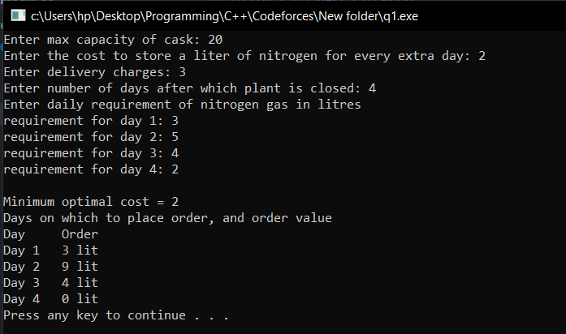

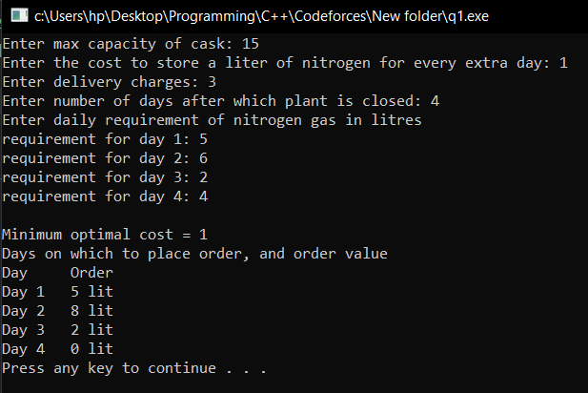

2. G is a simple, undirected, connected graph on n nodes with distinct, positive edge weights. Let T be a minimum spanning tree of G. Let e be some edge in G (which may or may not belong to T). We obtain a new graph G' from G by keeping everything the same except that we decrease the weight of 'e' by small quantity 'w' (still, all edge weights in G are distinct). Design an efficient algorithm that can find a minimum spanning tree T' of G', given G, T, e and its newly decreased weight w. Prove the correctness and analyze the runtime. (10)